CLASSICAL MECHANICS

**DOUBLE PENDULUM**

ADITYA SINGH 2K19/EP/005

horizontal line

# 

**INTRODUCTION**

A double pendulum is undoubtedly an actual miracle of nature. The jump in complexity, which is observed at the transition from a simple pendulum to a double pendulum is amazing. The oscillations of a simple pendulum are regular. For small deviations from equilibrium, these oscillations are harmonic and can be described by sine or cosine function. In the case of nonlinear oscillations, the period depends on the amplitude, but the regularity of the motion holds. In other words, in the case of a simple pendulum, the approximation of small oscillations fully reflects the essential properties of the system.

**ASSUMPTIONS**



Each pendulum consists of a point mass m hanging on an ideal ( non-elastic, mass-less) string of length l in a constant, homogeneous gravitational field of acceleration g. While the first pendulum is attached to a rigid, motionless point, the second pendulum is attached to the point mass of the first one.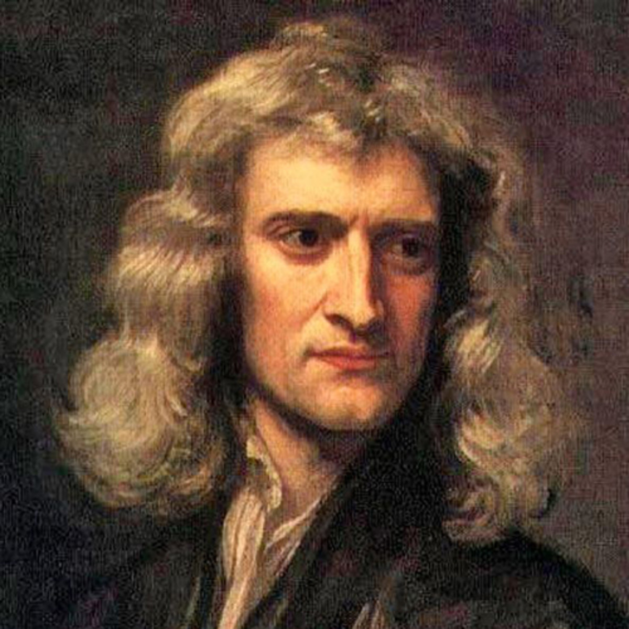

**Newton’s Method**

How should we approach this problem? As a naive, we might go ahead and try the only thing that we know how to use — Newton’s second law. We have two point masses in 3D space. The motion of each of these points can be described by the famous \vec{F} = m\vec{a}. Hence, considering each coordinate separately, we expect a total of six coupled equations that fully describe this system.

Writing down the forces, we realize that not only do we have to contend with gravity, but also with forces of tension between the point masses and the strings.

Since each pendulum is attached by a rigid string to a specific point, it will always be at a constant distance from this point — at a distance equal to the length of the string.This means that for each pendulum, there is only one (angular) degree of freedom remaining. The equation of motion (here, Newton’s second law) in two out of three of these degrees of freedom for each pendulum is trivial, since we have:

\phi_1: \qquad \phi_1 = \textrm{const} = 0 \quad \Leftrightarrow \quad \dot{\phi}_1 = 0

r_1: \qquad r_1 = \textrm{const} = l_1 \quad \Leftrightarrow \quad \dot{r}_1 = 0

And, of course, similar expressions apply for the second pendulum as well. Thus, four out of the six equations of motion are trivial! The system of equations we need to solve is thus:

m_1 l_1\dfrac{\textrm{d}^2\theta_1}{\textrm{d}t^2} = F_1\qquad m_2l_2 \dfrac{\textrm{d}^2\theta_2}{\textrm{d}t^2} =F_2

Seems much better now. However, we still don’t know what the relevant forces are. Of course, there will be the projection of the gravitational force in the angular direction. But there will also be a force due to one of the pendulums pulling on the other one.

And we expect this force to not only depend on the angles \theta_1 and \theta_2, but also on their velocities — after all, there should be some effect of the momentum, of the inertia of one of the pendulums on the movement of the other. What now?

**Euler-Lagrange Method**

**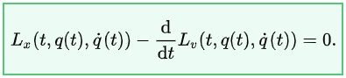**

Let us take a step back. Newton’s approach is very straightforward and conceptually simple. But it appears that this method is not very efficient in terms of formulating the equation of motion of a complex system.

Luckily, one of the cool things one learns in introductory mechanics classes is the Lagrange method. The gist of the Lagrange method lies in finding a suitable Lagrange function (or Lagrangian), and integrating it in time between some initial and final state of the system. The idea here is that this integral of the Lagrangian, called the action, should be minimal for the real trajectory of the system. This principle of least action constrains the behavior of the Lagrange function. An equation falls out of this thought process, the so-called Euler-Lagrange equation of motion:

\dfrac{\textrm{d}}{\textrm{d}t}\dfrac{\partial L}{\partial \dot{x}} = \dfrac{\partial L}{\partial x}

This is the equation the Lagrangian has to follow in order to minimize the action. Hence, it is the equation that defines the trajectory of the system.In classical mechanics, the choice of the Lagrangian is the difference between the kinetic energy and the potential energy of the system: L \equiv T - V

The kinetic energy is usually trivial, and reasoning about potential energy is nearly always easier than reasoning about multiple force vectors, action and reaction, etc. The Euler-Lagrange equation of motion is a second order differential equation, conceptually no more difficult than the second order second Newton’s law.

**Lagrangian Formalism**

First, let us write down the horizontal x and vertical y cartesian coordinates in terms of the relevant degrees of freedom. For the first pendulum we have:

x_1 = l_1 \sin(\theta_1)\qquad y_1 = -l_1 \cos(\theta_1)

This should be self-evident. The position of the second pendulum will look similar, it will just be offset by the position of the first pendulum:

x_2 = l_1\sin(\theta_1) +  l_2 \sin(\theta_2) \qquad y_2 = -l_1\cos(\theta_1) - l_2 \cos(\theta_2)

To express the Lagrangian, we need the potential energy, which depends on the vertical coordinates of the two pendulums, and the kinetic energy that is proportional to the square of the velocity. So, in order to get the velocity, we derive the coordinates above in time:

v_{x\,1} =  l_1 \cos(\theta_1)\dot{\theta}_1 \qquad v_{y\,1} = l_1 \sin(\theta_1)\dot{\theta}_1

v_{x\,2} =  l_1 \cos(\theta_1)\dot{\theta}_1 + l_2 \cos(\theta_2)\dot{\theta}_2\qquad v_{y\,2} = l_1 \sin(\theta_1)\dot{\theta}_1 + l_2 \sin(\theta_2)\dot{\theta}_2

The square of the velocity of the first pendulum is then:

v^2_1 = l_1^2 \sin^2(\theta_1)\dot{\theta}_1^2 + l_1^2 \cos^2(\theta_1)\dot{\theta}_1^2 = l_1^2 \dot{\theta}_1^2 \left[\sin^2(\theta_1) + \cos^2(\theta_1)\right] = \left(l_1 \dot{\theta}_1\right)^2

v^2_2 = \left(l_1\dot{\theta}_1\right)^2 + \left(l_2\dot{\theta}_2\right)^2 +2l_1l_2\dot{\theta}_1\dot{\theta}_2\cos(\theta_1 - \theta_2)

Now that we have rewritten our coordinates and velocities in terms of the two angular degrees of freedom of the system,

T = \dfrac{1}{2}m_1\left(l_1 \dot{\theta}_1\right)^2 + \dfrac{1}{2}m_2\left[\left(l_1\dot{\theta}_1\right)^2  + \left(l_2 \dot{\theta}_2\right)^2  + 2l_1l_2\dot{\theta}_1\dot{\theta}_2\cos(\theta_1 - \theta_2)\right]

V = -gl_1\left(m_1 + m_2 \right)\cos(\theta_1)  - m_2gl_2\cos(\theta_2)

We can now take this Lagrangian and plug it into the Euler-Lagrange equation of motion(s). Notice that while the kinetic energy only depends on both the velocities and position,

For \theta_1 we can write:

\dfrac{\textrm{d}}{\textrm{d}t}\dfrac{\partial L}{\partial \dot{\theta}_1} =  \dfrac{\textrm{d}}{\textrm{d}t} \left[m_1l_1^2\dot{\theta}_1 +  m_2l_1^2\dot{\theta}_1 + m_2l_1l_2\dot{\theta}_2\cos(\theta_1 - \theta_2)\right]

\qquad = \left(m_1 + m_2\right)l_1^2\ddot{\theta}_1 + m_2l_1l_2\ddot{\theta}_2\cos(\theta_1 - \theta_2) - m_2l_1l_2\dot{\theta}_2\sin(\theta_1 - \theta_2)\,(\dot{\theta}_1 - \dot{\theta}_2 )

The right hand side of the Euler-Lagrange EoM looks more tame in comparison:

\dfrac{\partial L}{\partial \theta_1} = -gl_1\left(m_1 + m_2\right)\sin(\theta_1) - m_2l_1l_2 \dot{\theta}_1\dot{\theta}_2\sin(\theta_1 - \theta_2)

We can do the same for the other coordinate, \theta_2:

\dfrac{\textrm{d}}{\textrm{d}t}\dfrac{\partial L}{\partial \dot{\theta}_2} = \dfrac{\textrm{d}}{\textrm{d}t} \left[m_2l_2^2\dot{\theta}_2  + m_2l_1l_2\dot{\theta}_1\cos(\theta_1 - \theta_2)\right]

\qquad =  m_2l_2^2\ddot{\theta}_2 + m_2l_1l_2\ddot{\theta}_1\cos(\theta_1 - \theta_2) - m_2l_1l_2\dot{\theta}_1\sin(\theta_1-\theta_2)\,(\dot{\theta}_1 - \dot{\theta}_2)

and

\dfrac{\partial L}{\partial \theta_2} = -gm_2l_2\sin(\theta_2) + m_2l_1l_2 \dot{\theta}_1\dot{\theta}_2\sin(\theta_1 - \theta_2)

Finally, we can combine all the above and write down the actual Euler-Lagrange EoM that determine the behavior of the system [drumroll intensifies]:

(1)\qquad \left(m_1 + m_2\right)l_1\ddot{\theta}_1 + m_2l_2\ddot{\theta}_2\cos(\theta_1 - \theta_2) - m_2l_2\dot{\theta}_2\sin(\theta_1 - \theta_2)\,(\dot{\theta}_1 - \dot{\theta}_2 ) =

-g\left(m_1 + m_2\right)\sin(\theta_1) - m_2l_2 \dot{\theta}_1\dot{\theta}_2\sin(\theta_1 - \theta_2)

(2) \qquad m_2l_2\ddot{\theta}_2 + m_2l_1\ddot{\theta}_1\cos(\theta_1 - \theta_2) - m_2l_1\dot{\theta}^2_1\sin(\theta_1-\theta_2) =-gm_2\sin(\theta_2) 

These equations can now be solved to determine the trajectory of the point masses. However, the mathematical nature of these coupled, second order differential equations makes any attempt at a solution very painful. In general, first order differential equations are much nicer to work with.

**Hamiltonian Formalism**

There is another way to describe physical problems. One that often makes use of the Lagrangian developed above, but which results in a set of two first order differential equations for each degree of freedom, instead of a single second order equation. The Lagrangian is defined as the difference between the kinetic and potential energy of a system. But the sum of these might also be of interest — after all, it is the total energy. And the total energy of an isolated system should be conserved, something that might prove helpful in our analysis.

Let us perform a Legendre transformation on the Lagrangian, moving from coordinates q_i and the corresponding velocities \dot{q}_i, to coordinates and the corresponding generalized momenta p_i. The Legendre transformation of the Lagrangian is the Hamiltonian:

H\left(p_i, q_i\right) \equiv \sum_i p_i \dot{q}_i - L

and in the absence of an explicit time dependence of the Lagrangian, it represents the total energy of the system. The generalized momenta are nothing other than:

p_i \equiv \dfrac{\partial L}{\partial \dot{q}_i}

This is something we already calculated for our coordinates \theta_1 and \theta_2. Once we write down the Hamiltonian (as a function of coordinates and their momenta only), we can compute the trajectory of the system using Hamilton’s equations of motion:

\dot{q}_i = \dfrac{\partial H}{\partial p_i} \qquad \textrm{and} \qquad \dot{p}_i = \dfrac{\partial H}{\partial q_i}

We first express the generalized momenta:

(3) \qquad \dfrac{\partial L}{\partial \dot{\theta}_1}   = p_1 = \left(m_1 + m_2\right)l_1^2\dot{\theta}_1 + m_2l_1l_2\dot{\theta}_2\cos(\theta_1 - \theta_2)

(4) \qquad \dfrac{\partial L}{\partial \dot{\theta}_2} = p_2 = m_2l_2^2\dot{\theta}_2 + m_2l_1l_2\dot{\theta}_1\cos(\theta_1 - \theta_2)

which means that:

\sum_i p_i \dot{q}_i = \left(m_1 + m_2\right)l_1^2\dot{\theta}_1^2 +  m_2l_2^2\dot{\theta}_2^2 + 2 m_2l_1l_2\dot{\theta}_1\dot{\theta}_2\cos(\theta_1 - \theta_2)

With the Lagrangian being:

L = \dfrac{1}{2}\left(m_1 + m_2\right) l_1^2 \dot{\theta}_1^2 + \dfrac{1}{2}m_2l_2^2\dot{\theta}_2^2    + m_2l_1l_2\dot{\theta}_1\dot{\theta}_2\cos(\theta_1 - \theta_2) + 

+ gl_1\left(m_1 + m_2 \right)\cos(\theta_1) + m_2gl_2\cos(\theta_2)

the Hamiltonian must be:

H \equiv \sum_i p_i \dot{q}_i - L = \dfrac{1}{2}\left(m_1 + m_2\right) l_1^2 \dot{\theta}_1^2 + \dfrac{1}{2}m_2l_2^2\dot{\theta}_2^2 + m_2l_1l_2\dot{\theta}_1\dot{\theta}_2\cos(\theta_1 - \theta_2) + 

- gl_1\left(m_1 + m_2 \right)\cos(\theta_1) - m_2gl_2\cos(\theta_2)

Unfortunately, we are not done yet. The Hamiltonian is a function of the coordinates \theta_1, \theta_2, p_1, and p_2. We must express \dot{\theta}_1 and \dot{\theta}_2 as functions of generalized positions and momenta. To that end, we isolate \dot{\theta}_2 in eq. (4):

p_2 = m_2l_2^2\dot{\theta}_2 + m_2l_1l_2\dot{\theta}_1\cos(\theta_1 - \theta_2)

m_2l_2^2\dot{\theta}_2 = p_2 - m_2l_1l_2\dot{\theta}_1\cos(\theta_1 - \theta_2)

\dot{\theta}_2 = \dfrac{p_2}{m_2l_2^2} - \dfrac{l_1}{l_2}\dot{\theta}_1\cos(\theta_1 - \theta_2)

and plug into eq. (3):

p_1 = \left(m_1 + m_2\right)l_1^2\dot{\theta}_1 + m_2l_1l_2\cos(\theta_1 - \theta_2)\left[\dfrac{p_2}{m_2l_2^2} - \dfrac{l_1}{l_2}\dot{\theta}_1\cos(\theta_1 - \theta_2)\right]

Let us gather all terms that contain \dot{\theta}_1:

\dot{\theta}_1\left[\left(m_1 + m_2\right)l_1^2 -m_2l_1^2\cos^2(\theta_1 - \theta_2)\right] = p_1 - p_2\dfrac{l_1}{l_2}\cos(\theta_1 - \theta_2) 

whence:

\dot{\theta}_1 = \dfrac{p_1 - p_2\dfrac{l_1}{l_2}\cos(\theta_1 - \theta_2)}{\left(m_1 + m_2\right)l_1^2 -m_2l_1^2\cos^2(\theta_1 - \theta_2)} 

Multiplying both the numerator and the denominator by l_2, and rearranging some terms, we get:

\dot{\theta}_1 = \dfrac{l_2p_1 - l_1p_2\cos(\theta_1 - \theta_2)}{l_1^2l_2\left[m_1 + m_2 -m_2\cos^2(\theta_1 - \theta_2)\right]} 

where we use the good ol’ trigonometric identity \sin^2(x) + \cos^2(x) = 1 to find the final expression:

\dot{\theta}_1 = \dfrac{l_2p_1 - l_1p_2\cos(\theta_1 - \theta_2)}{l_1^2l_2\left[m_1 +m_2\sin^2(\theta_1 - \theta_2)\right]} 

We could perform a similar procedure, expressing \dot{\theta}_1 from eq. (3), plugging into eq. (4) and solving for \dot{\theta}_2 to find:

\dot{\theta}_2 = \dfrac{l_1\left(m_1 + m_2\right)p_2 - l_2m_2p_1\cos(\theta_1-\theta_2)}{l_1l_2^2m_2\left[m_1 + m_2\sin^2(\theta_1 - \theta_2)\right]}

What we need to do now is plug the expressions for \dot{\theta}_1 and \dot{\theta}_2 into the Hamiltonian, and then derive with respect to the generalized positions \theta_1 and \theta_2 in order to find the two other Hamilton’s equations. This is a rather lengthy calculation, one I would like to avoid if at all possible.

Acknowledging this caveat, we finally arrive at Hamilton’s equations of motion:

\dot{\theta}_1 = \dfrac{l_2p_1 - l_1p_2\cos(\theta_1-\theta_2)}{l_1^2l_2\left[m_1 + m_2\sin^2(\theta_1 - \theta_2)\right]}

\dot{\theta}_2 = \dfrac{l_1\left(m_1 + m_2\right)p_2 - l_2m_2p_1\cos(\theta_1-\theta_2)}{l_1l_2^2m_2\left[m_1 + m_2\sin^2(\theta_1 - \theta_2)\right]}

\dot{p}_1 = -\left(m_1 + m_2\right)gl_1\sin(\theta_1) - A + B

\dot{p}_2 = -m_2gl_2\sin(\theta_2) + A - B

where

A \equiv \dfrac{p_1p_2\sin(\theta_1 - \theta_2)}{l_1l_2\left[m_1 + m_2\sin^2(\theta_1 - \theta_2)\right]}

B \equiv \dfrac{l_2^2m_2p_1^2 + l_1^2\left(m_1 + m_2\right)p_2^2 - l_1l_2m_2p_1p_2\cos(\theta_1 - \theta_2)}{2l_1^2l_2^2\left[m_1 + m_2\sin^2(\theta_1 - \theta_2)\right]^2}\sin\left[2(\theta_1 - \theta_2)\right]

There, done. We eventually succeeded in writing down the equations of motion of the two masses in a double pendulum. And we did this in a form that is very conducive to numerical simulations.

**Python Simulation**

We will assume that the lengths of the two pendulums are identical and equal to one, l_1 = l_2 = 1. We will also set the masses to m_1 = m_2 = 1. This greatly simplifies our equations:

\dot{\theta}_1 = \dfrac{p_1 - p_2\cos(\theta_1-\theta_2)}{1 + \sin^2(\theta_1 - \theta_2)}

\dot{\theta}_2 = \dfrac{2p_2 - p_1\cos(\theta_1-\theta_2)}{1 + \sin^2(\theta_1 - \theta_2)}

\dot{p}_1 = -2g\sin(\theta_1) -  \dfrac{p_1p_2\sin(\theta_1 - \theta_2)}{1 + \sin^2(\theta_1 - \theta_2)}  +   \dfrac{p_1^2 + 2p_2^2 - p_1p_2\cos(\theta_1 - \theta_2)}{2\left[1 + \sin^2(\theta_1 - \theta_2)\right]^2}\sin\left[2(\theta_1 - \theta_2)\right] 

\dot{p}_2 = -g\sin(\theta_2) +   \dfrac{p_1p_2\sin(\theta_1 - \theta_2)}{1 + \sin^2(\theta_1 - \theta_2)}  - \dfrac{p_1^2 + 2p_2^2 - p_1p_2\cos(\theta_1 - \theta_2)}{2\left[1 + \sin^2(\theta_1 - \theta_2)\right]^2}\sin\left[2(\theta_1 - \theta_2)\right] 

We have chosen to always start from a state in which the initial velocities are zero.

polar\_to\_cartesian() method takes the current position of the two masses in terms of angles and lengths, and transforms them into Cartesian coordinates (horizontal and vertical positions). The method returns an array of the coordinates corresponding to the pivot, the first, and the second mass of the pendulum, respectively.

FuncAnimation() function from the animation module of the matplotlib package.



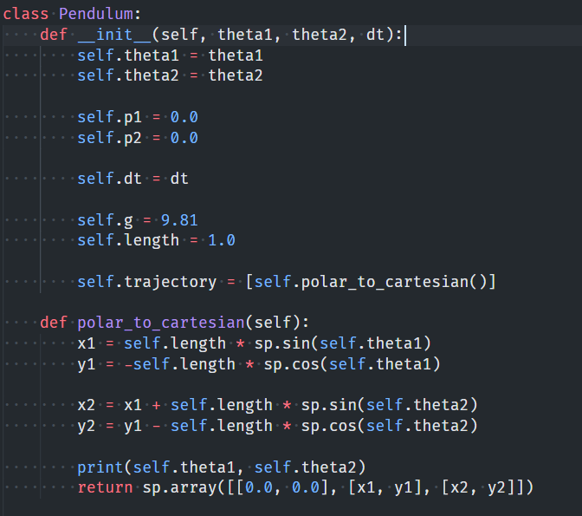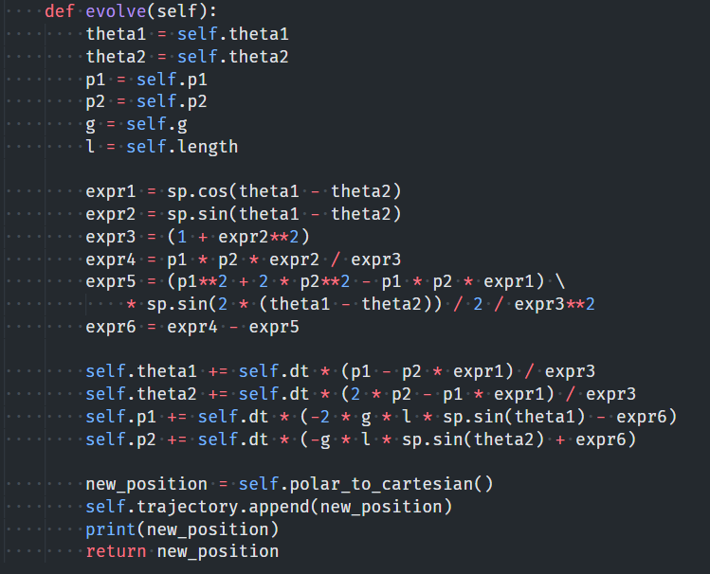

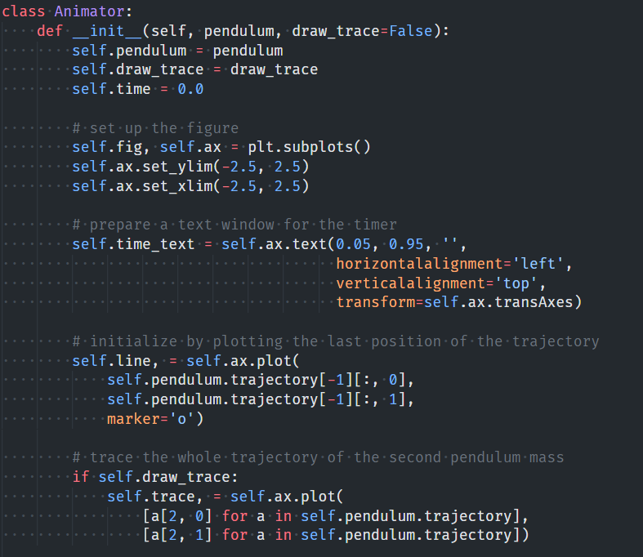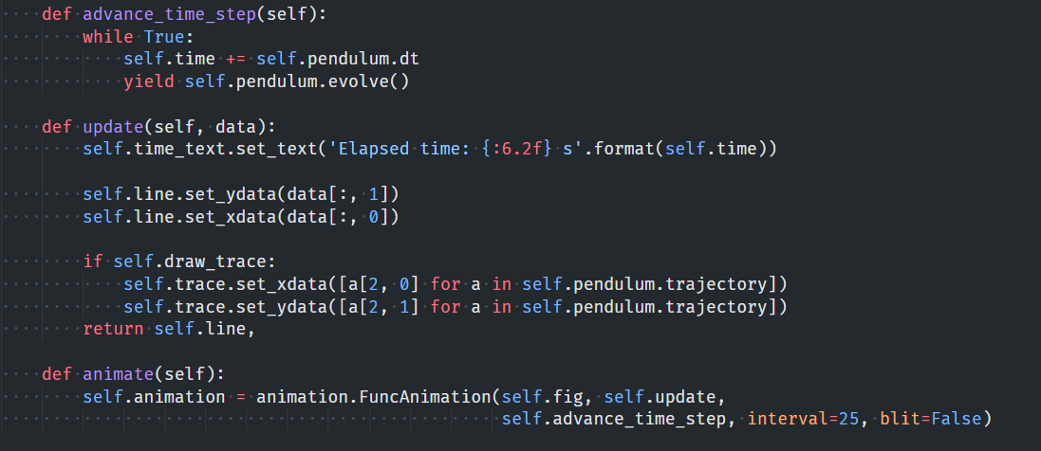

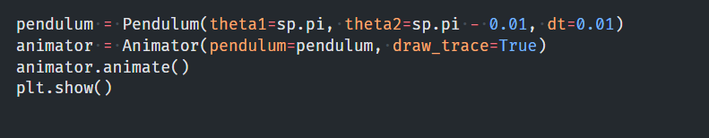

**OUTPUT**



**END**